**Homework July 16, 2021**

Write a Python program to sum all the items in a list.  
Example: [1, 2, 3, 4] Result: 10

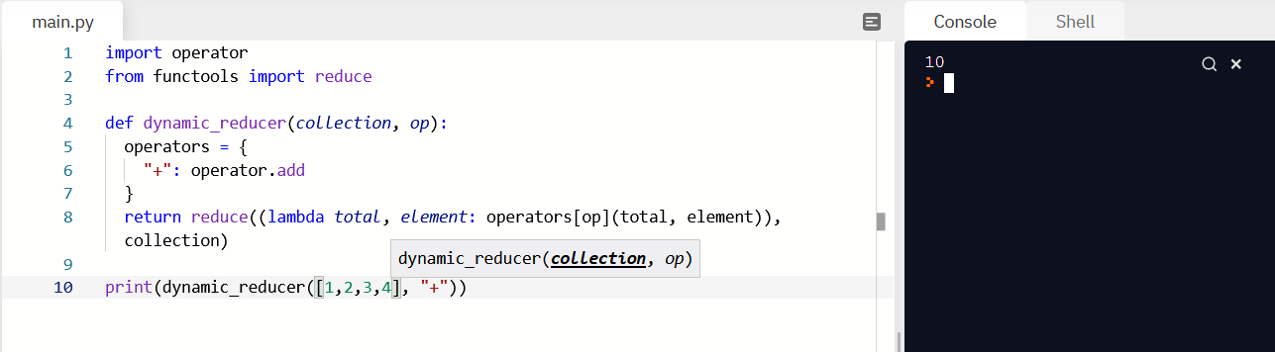

Iterative Approach

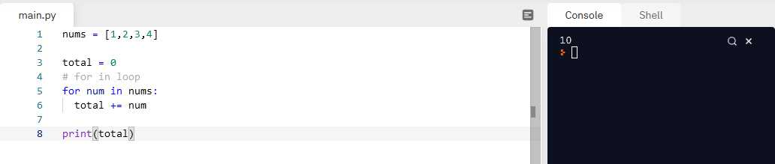

Functional Approach

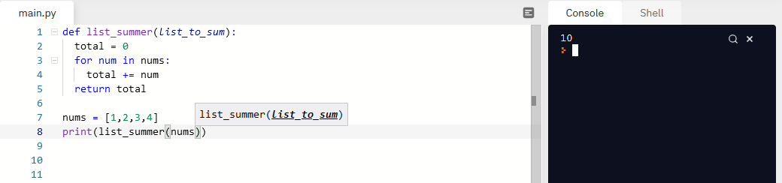

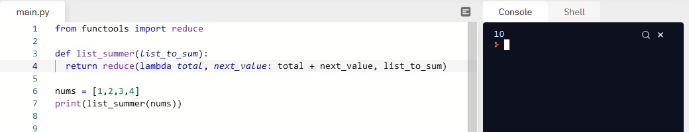

Sum Function

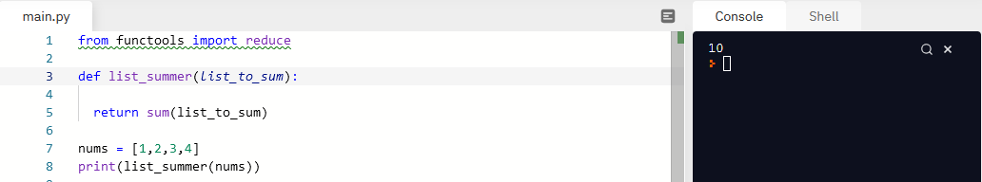

Write a Python program to print a specified list after removing the 0th, 4th and 5th elements.  
Example: : ['Red', 'Green', 'White', 'Black', 'Pink', 'Yellow']  
Result: ['Green', 'White', 'Black']

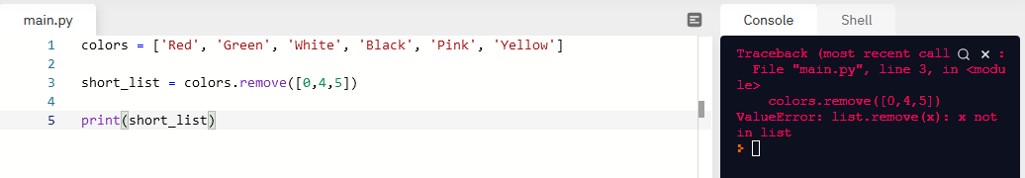

.pop

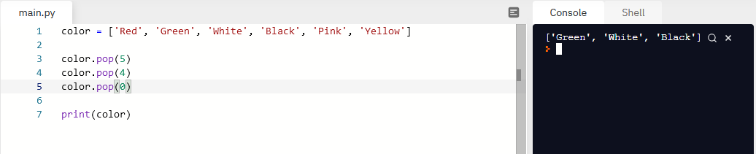

Write a Python program that accepts a comma separated STRING of words as input and prints the unique words in sorted form (alphanumerically) AS A STRING.  
Example: "red, white, black, green, blue" (This is a string!!!)  
Result: "black, blue, green, red, white" (This is also a string!!!)

